**Project Proposal**

**For**

**Project R**

|  |  |
| --- | --- |
| **Instructor:** | Professor Forte |
| **Team Members:** | Min Dye, Scott Hargrove, Peter Wainwright, Ryan Do |
| **Cycle:** | 1 |
| **Date Submitted:** | 31 Jan 2018 |

Document template copyright 2015, CCI Faculty, Version 2.0. Use permitted under Creative Commons license CC-BY-NC-SA. See http://creativecommons.org/licenses/by-nc-sa/3.0/

**Project Proposal**

This report documents the initial definition of the project. It includes an abstract and project overview. It also includes a summary of issues related to the project and to the team.

**Project**

## **Project Name: Project R**

## **Abstract**

The project is a side-scrolling roguelike game that aims to provide enjoyable experiences to the players. Different maps and enemies will be designed to challenge players. We are motivated for the project because we want to share our our creative ideas and passion to the public.

The game will showcase different mechanics such as permanent death, different weapons and armors, challenging monsters, equipment augmentation, etc.

Team members will face challenges that include time constraints, learning how to properly utilize Unity, the game engine being used for the project, and creating visuals.The plan includes several tasks: gameplay design, level design, progression design, and incorporating different genres (roguelike, trivia, and puzzle). The most important task is to build a functional game with controllable character and enemies.

Final deliverable will be a video game on Windows platform.

## **Project Deliverables**

The final product will include main menu buttons, character movements, combat system, equipment system, item drop system, currency, pause menu, etc. The game will be playable with keyboard.

## **Resources**

Team members require computers suitable to run Unity.

We will use Unity Team for group development.

Piskel, an online sprite editor, will be used

## **Expertise**

Primary:

Developmental Skills

Leadership

Stenography

Secondary:

Graphic Design

Music Design

Storytelling

**Team**

## **Team Members and Roles**

Figure 1, below, identifies all the team members and the initial role assigned to each person.

|  |  |
| --- | --- |
| **Name** | **Role** |
| Min Dye | Project Director |
| Scott Hargrove | Vice-Project Director, Lead Designer |
| Ryan Do | Developer, Scribe |
| Peter Wainwright | Application Developer |

**Figure 1 - Team Members and Roles**

Timeline

The figure below shows the initially identified set of activities for this cycle. [Instr7]

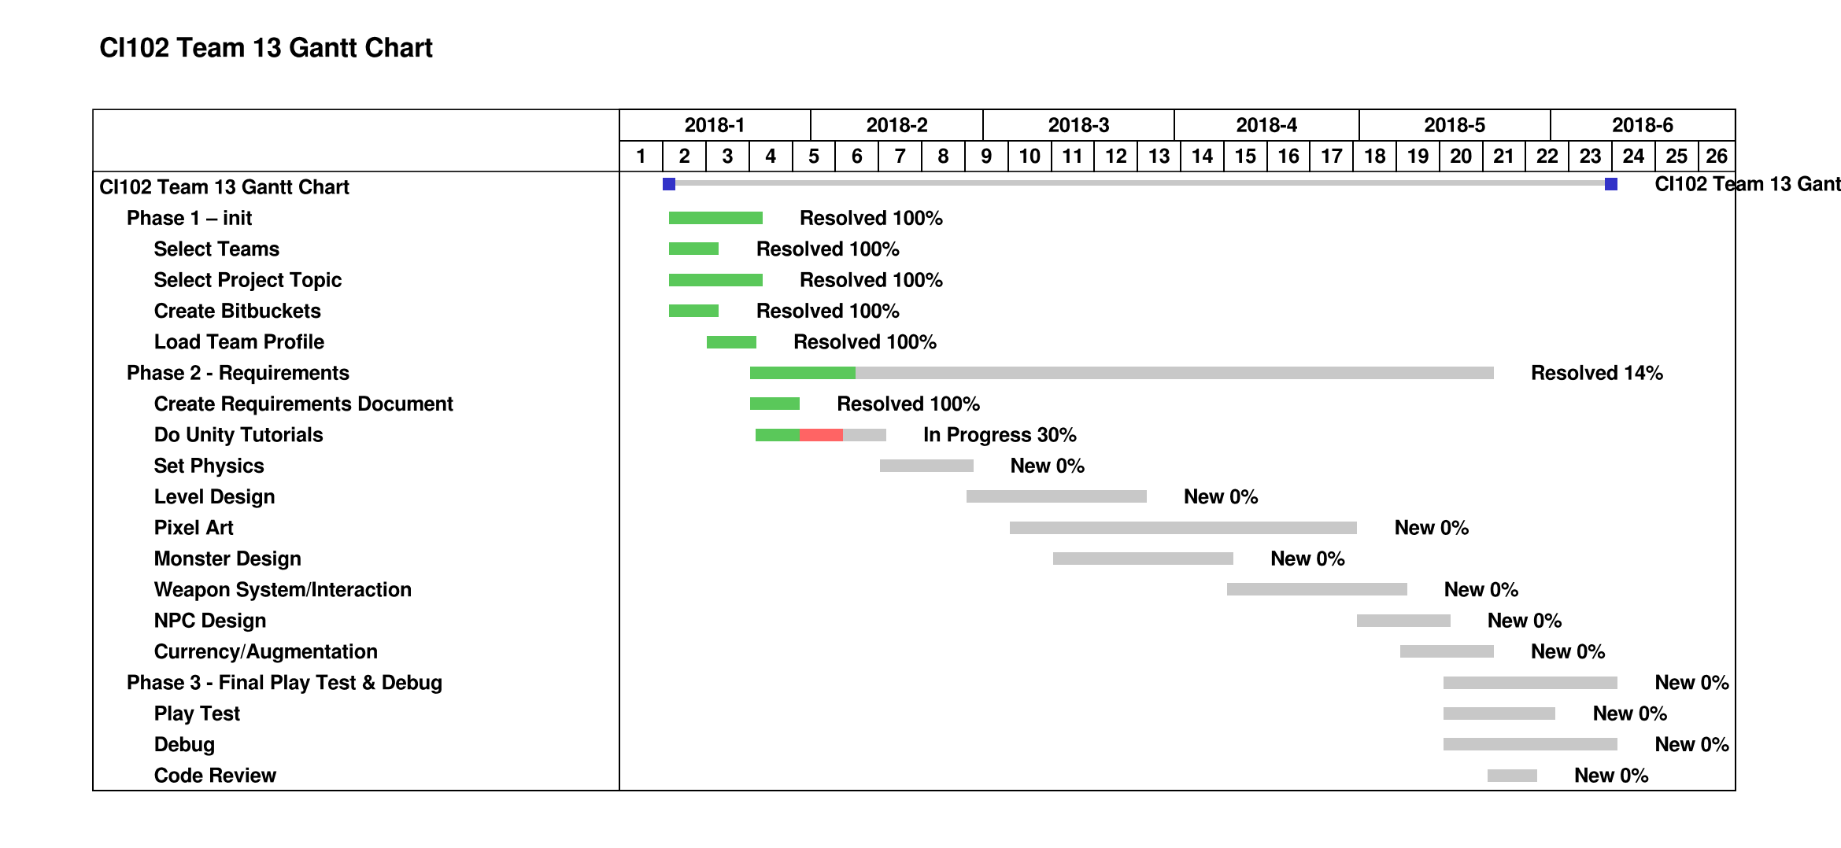

**Figure 2 – Project Timeline**